C:\Users\mary catherine\AppData\Local\Microsoft\Windows\Temporary Internet Files\Content.IE5\D2QFBNR3\MC900088442[1].wmf

See you later, a, a,a, alligator

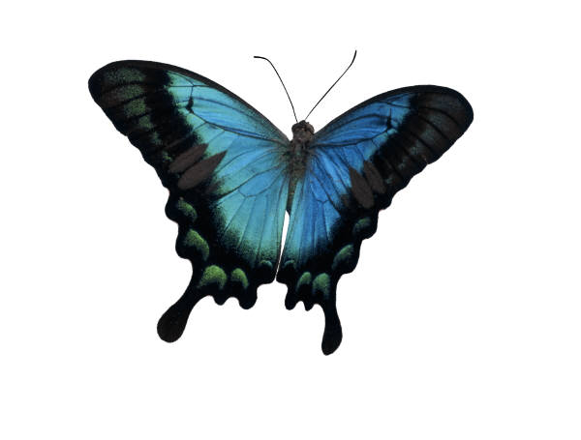

Bye-bye, b,b,b, butterfly

C:\Users\mary catherine\AppData\Local\Microsoft\Windows\Temporary Internet Files\Content.IE5\D2QFBNR3\MC900215228[1].wmf

In a while, c,c,c, crocodile

C:\Users\mary catherine\AppData\Local\Microsoft\Windows\Temporary Internet Files\Content.IE5\D2QFBNR3\MC900140543[1].wmfOut the door d,d,d, dinosaur

C:\Users\mary catherine\AppData\Local\Microsoft\Windows\Temporary Internet Files\Content.IE5\GRLTSLUN\MC900013243[1].wmf

Fly regal like an e, e,e, eagle

C:\Users\mary catherine\AppData\Local\Microsoft\Windows\Temporary Internet Files\Content.IE5\D2QFBNR3\MC900331922[1].wmfC:\Users\mary catherine\AppData\Local\Microsoft\Windows\Temporary Internet Files\Content.IE5\D2QFBNR3\MC900331922[1].wmf

C:\Users\mary catherine\AppData\Local\Microsoft\Windows\Temporary Internet Files\Content.IE5\D2QFBNR3\MC900331922[1].wmf

Close your eyes little f,f,f,

flies

C:\Users\mary catherine\AppData\Local\Microsoft\Windows\Temporary Internet Files\Content.IE5\PJCEHX8E\MC900192209[1].wmf

Stay well, g,g,g, gazelle

C:\Users\mary catherine\AppData\Local\Microsoft\Windows\Temporary Internet Files\Content.IE5\D2QFBNR3\MC900269764[1].wmf

Follow the flock h,h,h, hawk

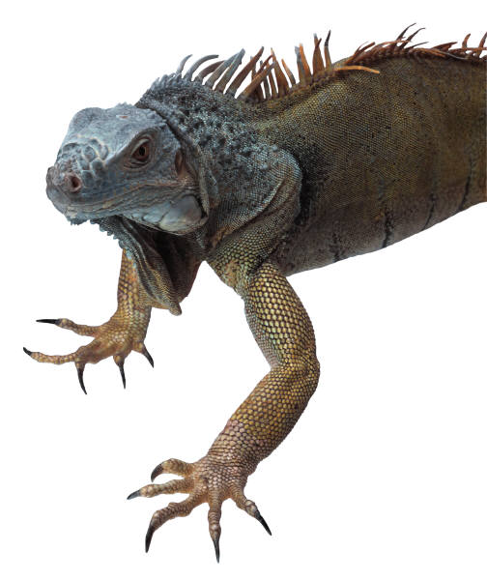

See you manana, spiky i,i,i, iguana

C:\Users\mary catherine\AppData\Local\Microsoft\Windows\Temporary Internet Files\Content.IE5\GRLTSLUN\MC900048552[1].wmf

Don`t go far j,j,j, jaguar

C:\Users\mary catherine\AppData\Local\Microsoft\Windows\Temporary Internet Files\Content.IE5\1PV5F5JN\MC900111356[1].wmf

Toodle-oo, k,k,k,

kangaroo



Give a hug, l,l,l, ladybug

C:\Users\mary catherine\AppData\Local\Microsoft\Windows\Temporary Internet Files\Content.IE5\GRLTSLUN\MC900417366[1].wmf

To your house, little m,m,m, mouse

C:\Users\mary catherine\AppData\Local\Microsoft\Windows\Temporary Internet Files\Content.IE5\GRLTSLUN\MC900053116[1].wmf

Time to scoot, warty n,n,n, newt

C:\Users\mary catherine\AppData\Local\Microsoft\Windows\Temporary Internet Files\Content.IE5\1PV5F5JN\MC900135087[1].wmf

To the bus o,o,o, octopus

C:\Users\mary catherine\AppData\Local\Microsoft\Windows\Temporary Internet Files\Content.IE5\D2QFBNR3\MC900133521[1].wmf

In a line, p,p,p, porcupine

C:\Users\mary catherine\AppData\Local\Microsoft\Windows\Temporary Internet Files\Content.IE5\D2QFBNR3\MC900332392[1].wmf

Hit the trail, little q,q,q quail

C:\Users\mary catherine\AppData\Local\Microsoft\Windows\Temporary Internet Files\Content.IE5\PJCEHX8E\MC900131253[1].wmf

See you soon masked r,r,r, raccoon

C:\Users\mary catherine\AppData\Local\Microsoft\Windows\Temporary Internet Files\Content.IE5\GRLTSLUN\MC900034130[1].wmf

Blow a kiss, s,s,s, starfish

C:\Users\mary catherine\AppData\Local\Microsoft\Windows\Temporary Internet Files\Content.IE5\1PV5F5JN\MC900020454[1].wmf

Hit the road, hoppy t,t,t, toad

C:\Users\mary catherine\AppData\Local\Microsoft\Windows\Temporary Internet Files\Content.IE5\D2QFBNR3\MC900203156[1].wmf

Hear the horn, u,u,u, unicorn

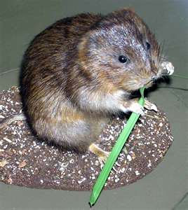

To your hole, tiny v,v,v, vole

C:\Users\mary catherine\AppData\Local\Microsoft\Windows\Temporary Internet Files\Content.IE5\GRLTSLUN\MC900140655[1].wmf

Set sail, big blue w,w,w, whale

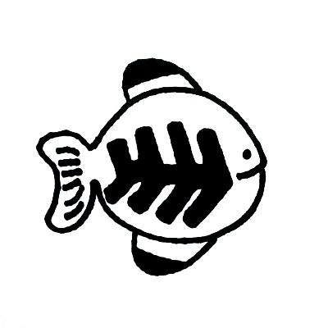

Make a wish, x,x,x, x-ray-fish

C:\Users\mary catherine\AppData\Local\Microsoft\Windows\Temporary Internet Files\Content.IE5\1PV5F5JN\MC900084186[1].wmf

Pack your knapsack, hairy y,y,y, yak

C:\Users\mary catherine\AppData\Local\Microsoft\Windows\Temporary Internet Files\Content.IE5\PJCEHX8E\MC900111360[1].wmf

Carry your bag, z,z,z, zigzag

C:\Users\mary catherine\AppData\Local\Microsoft\Windows\Temporary Internet Files\Content.IE5\1PV5F5JN\MC900438233[1].wmf

Come back and play another day.